**1. Write a program that accepts an array by 10 names and display all**

**names that end with “h”.**

**// SOURCE CODE**

import java.util.Scanner;

public class StringValidation {

public static void main(String[] args) {

Scanner scanner = new Scanner(System.in);

String[] names = new String[10];

System.out.println("Enter 10 names:");

for (int i = 0; i < 10; i++) {

names[i] = scanner.nextLine();

}

System.out.println("Names ending with 'h':");

for (String name : names) {

if (name.endsWith("h")) {

System.out.println(name);

}

}

}

}

**OUTPUT :**

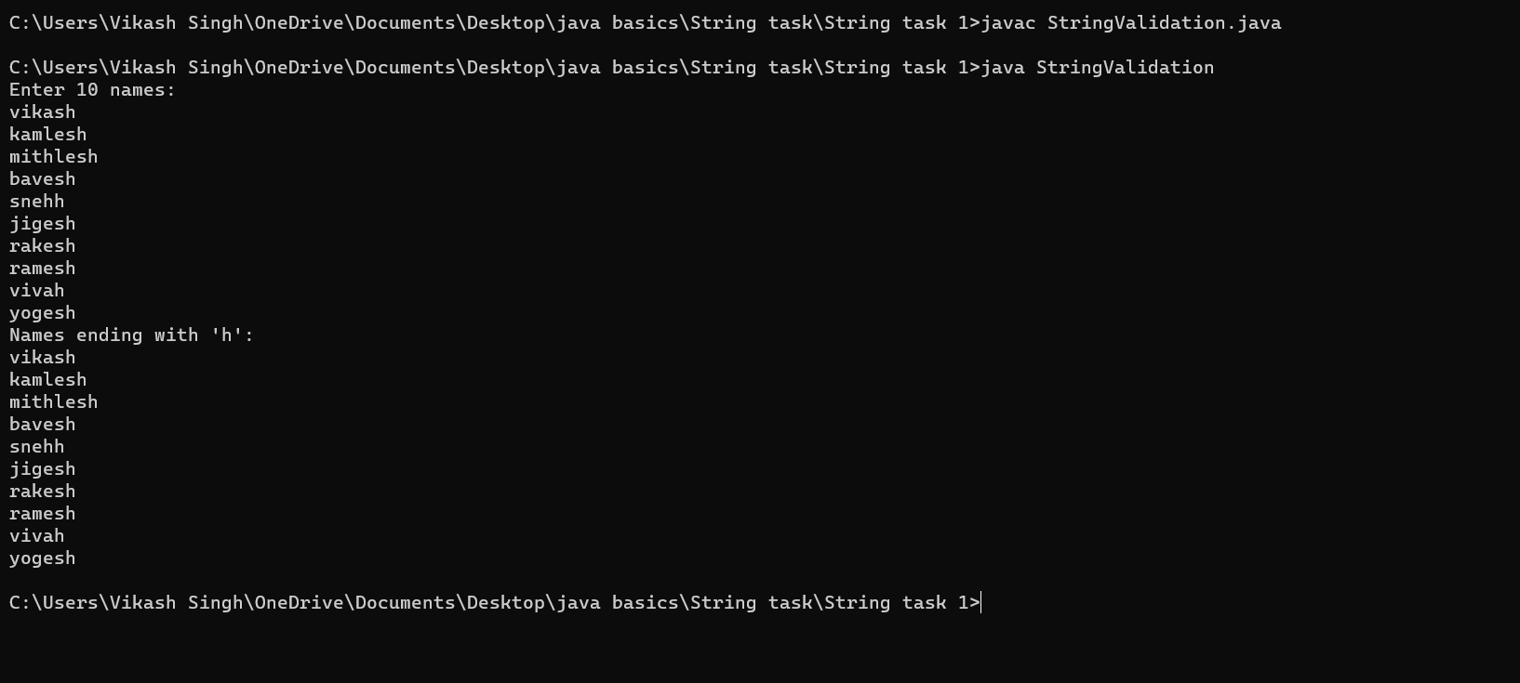

**2. Write a program that accepts an array by 10 names and display all**

**names that contain “he”.**

**// SOURCE CODE**

import java.util.Scanner;

public class StringValidation {

public static void main(String[] args) {

Scanner scanner = new Scanner(System.in);

String[] names = new String[10];

System.out.println("Enter 10 names:");

for (int i = 0; i < 10; i++) {

names[i] = scanner.nextLine();

}

System.out.println("Names containing 'he':");

for (String name : names) {

if (name.contains("he")) {

System.out.println(name);

}

}

}

}

**OUTPUT:**

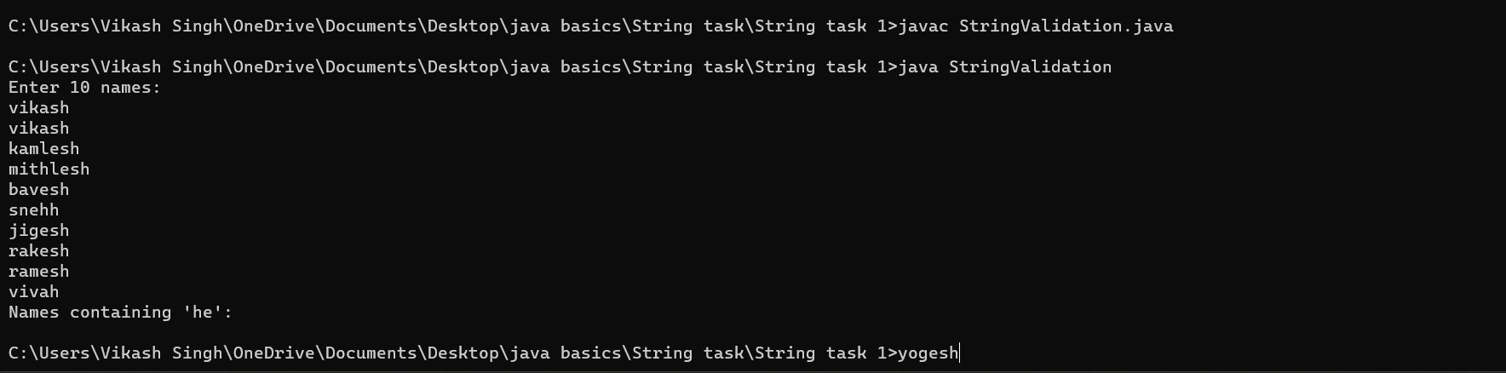

**3. Write a program in java to extract a substring from a given string.**

**Test Data :**

**Input the string : this is test string**

**Input the position to start extraction :9**

**Input the length of substring :4**

**Expected Output :**

**The substring retrieve from the string is : &quot; test &quot;**

**// SOURCE CODE**

import java.util.Scanner;

public class SubstringExtraction {

public static void main(String[] args) {

Scanner scanner = new Scanner(System.in);

System.out.println("Input the string:");

String inputString = scanner.nextLine();

System.out.println("Input the position to start extraction:");

int startPosition = scanner.nextInt();

System.out.println("Input the length of substring:");

int length = scanner.nextInt();

String substring = inputString.substring(startPosition, startPosition + length);

System.out.println("The substring retrieved from the string is: \"" + substring + "\"");

}

}

**// OUTPUT:**

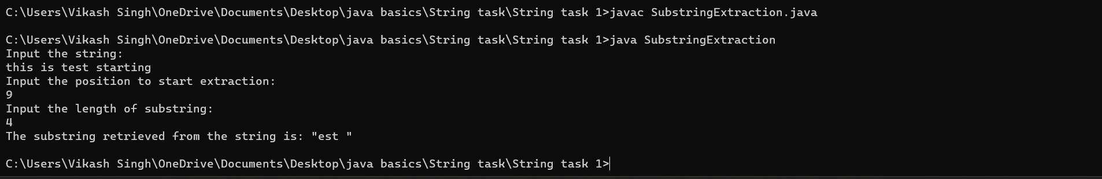

**4. Write a program in java to print individual characters of string in reverse**

**order.**

**Test Data :**

**Input the string : welcome**

**Expected Output :**

**The characters of the string in reverse are :**

**// SOURCE CODE**

import java.util.Scanner;

public class ReverseCharacters {

public static void main(String[] args) {

Scanner scanner = new Scanner(System.in);

System.out.println("Input the string:");

String inputString = scanner.nextLine();

System.out.println("The characters of the string in reverse are:");

for (int i = inputString.length() - 1; i >= 0; i--) {

System.out.print(inputString.charAt(i));

}

}

}

**// OUTPUT:**

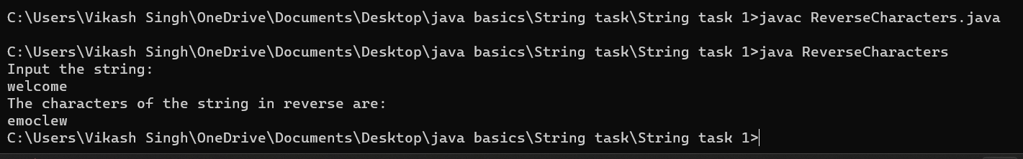

**5.  Write a program in java to count the total number of words in a string.**

**Test Data :**

**Input the string : welcome to bhopal**

**Expected Output :**

**Total number of words in the string is : 3**

**// SOURCE CODE**

import java.util.Scanner;

public class WordCount {

public static void main(String[] args) {

Scanner scanner = new Scanner(System.in);

System.out.println("Input the string:");

String inputString = scanner.nextLine();

String[] words = inputString.split("\\s+");

int wordCount = words.length;

System.out.println("Total number of words in the string is: " + wordCount);

}

}

**// OUTPUT:**

